# Assignment Answer Sheet

|  |  |  |  |
| --- | --- | --- | --- |
| **Campus** | Pretoria | **Faculty** | IT |
| **Module Code** | ITECA | **Module Name** |  |
| **Student Name** | Arno Moller | | |
| **Student Number** | CC96ZRRS5 | | |

Declaration

“I declare that this assignment is my own original work except for source material explicitly acknowledged, and that the same or related material has not been previously, or is being simultaneously, submitted for this or any other course. I also acknowledge that I am aware of the Institution’s policy and regulations on honesty in academic work as set out in the Eduvos Conditions of Enrolment, and of the disciplinary guidelines applicable to breaches of such policy and regulations.”

*Start writing from here.*

***Question 3***

a)

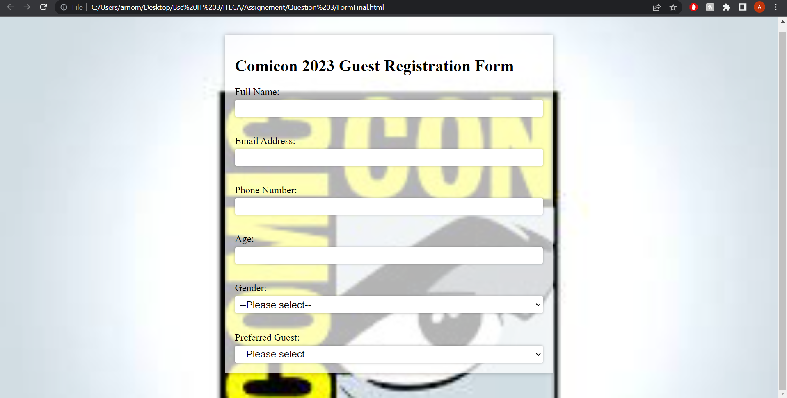

Figure 1 Message upon successful registration

Figure 2 Guest Registration Form

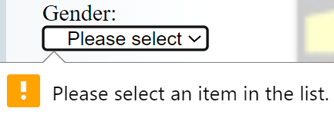

Figure 3 Message showing when required field is missing

***Code:***

<!DOCTYPE html>

<html>

<head>

<title>Comicon 2023 Guest Registration Form</title>

<style>

body {

background-image: url("back.jpg");

background-size: cover;

}

.container {

background-color: rgba(255, 255, 255, 0.7);

padding: 20px;

margin: 50px auto;

max-width: 600px;

box-shadow: 0px 0px 10px rgba(0, 0, 0, 0.3);

}

form {

display: flex;

flex-direction: column;

justify-content: space-between;

}

label {

font-size: 1.2em;

margin-bottom: 5px;

}

input,

select {

font-size: 1.2em;

padding: 5px;

border: none;

border-radius: 3px;

box-shadow: 0px 0px 5px rgba(0, 0, 0, 0.3);

}

input[type="checkbox"] {

transform: scale(1.5);

margin-right: 10px;

}

input[type="submit"] {

background-color: #4CAF50;

color: white;

padding: 10px 20px;

font-size: 1.2em;

border: none;

border-radius: 3px;

cursor: pointer;

box-shadow: 0px 0px 5px rgba(0, 0, 0, 0.3);

}

input[type="submit"]:hover {

background-color: #3e8e41;

}

</style>

</head>

<body>

<div class="container">

<h1>Comicon 2023 Guest Registration Form</h1>

<form method="post" action="Formphp.php">

<label for="full_name">Full Name:</label>

<input type="text" name="full_name" id="full_name" required>

<br><br>

<label for="email">Email Address:</label>

<input type="email" name="email" id="email" required>

<br><br>

<label for="phone">Phone Number:</label>

<input type="tel" name="phone" id="phone" required>

<br><br>

<label for="age">Age:</label>

<input type="number" name="age" id="age" min="18" max="99" required>

<br><br>

<label for="gender">Gender:</label>

<select name="gender" id="gender" required>

<option value="">--Please select--</option>

<option value="male">Super MAN</option>

<option value="female">Super Woman</option>

</select>

<br><br>

<label for="guest_type">Preferred Guest:</label>

<select name="guest_type" id="guest_type" required>

<option value="">--Please select--</option>

<option value="comic_artist">Comic Artist and Designer</option>

<option value="writer">Writer</option>

<option value="actor">Actor</option>

<option value="cosplayer">Cosplayer</option>

<option value="other">Other</option>

</select>

***PHP code***

<style type="text/css">

button {

text-align: center;

background-color: red;

width: 100px;

height: 40px;

}

form{

text-align: center;

}

</style>

<?php

$server="localhost";

$username="root";

$pass="";

$conn=mysqli_connect($server,$username,$pass);

if (!$conn) {

die("connection failed". mysqli_connect_error());

}

$Full_Name=$_POST['fullname'];

$Email=$_POST['email'];

$Phone_Number=$_POST['phonenumber'];

$Age=$_POST['age'];

$Gender=$_POST['gender'];

$Preffered_Guest=$_POST['prefferedguest'];

$sql="INSERT INTO `feedback` . `form` (`fullname`,`email`,`phonenumber`,`age`,'gender', 'prefferedguest') VALUES ('$Full_Name','$Email','$Phone_Number','$Age', '$Gender', '$Preffered_Guest');";

if ($conn->query($sql)==TRUE) {

echo "<h3 > The team has received your query, and will respond as soon as possible. <h3><br>";

echo "<form action='http://localhost/FormFinal.html'>

<button type='submit' > HOME </button>

</form>";

}

else {

echo "ERROR : $sql <br> $conn->error()";

}

$conn->close();

?>

b)

TO : [Guest_Mail]

Greetings fellow ComiCon hero, [Guest Name]

We are just excited as you are for this year’s ComiCon! We appreciate your interest in Comicon 2023. Being a part of our community excites us.

You'll be the first to learn about our newest announcements, special deals, and updates as a registered guest. Keep an eye on your email inbox because we'll send you updates.

Please feel free to get in touch with us by writing an email to *comicon.com*, if you have any questions or issues in the interim.

Once again, we appreciate your attendance at Comicon 2023 and can’t wait to see you!

In Stan Lee’s magnificent words:

Excelsior True Believer!

Best wishes

ComiCon Team

c)

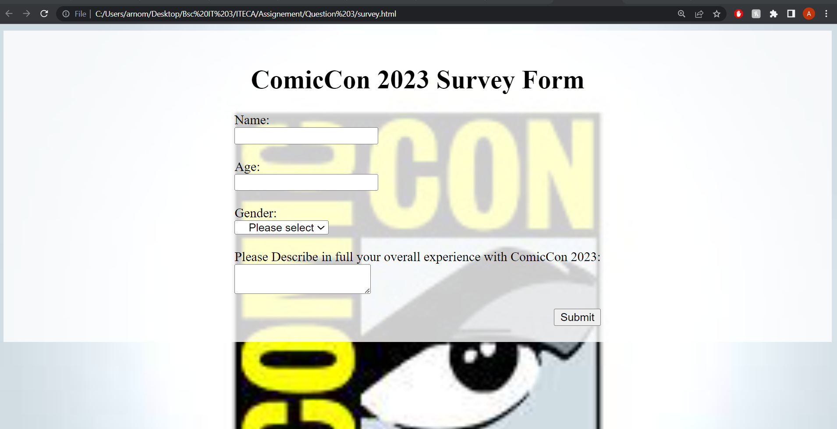

Figure 4 Survey Form

Figure 5 Option when selecting gender to make it more engaging.

Figure 6 User must complete the fields to submit the survey.

***Code***

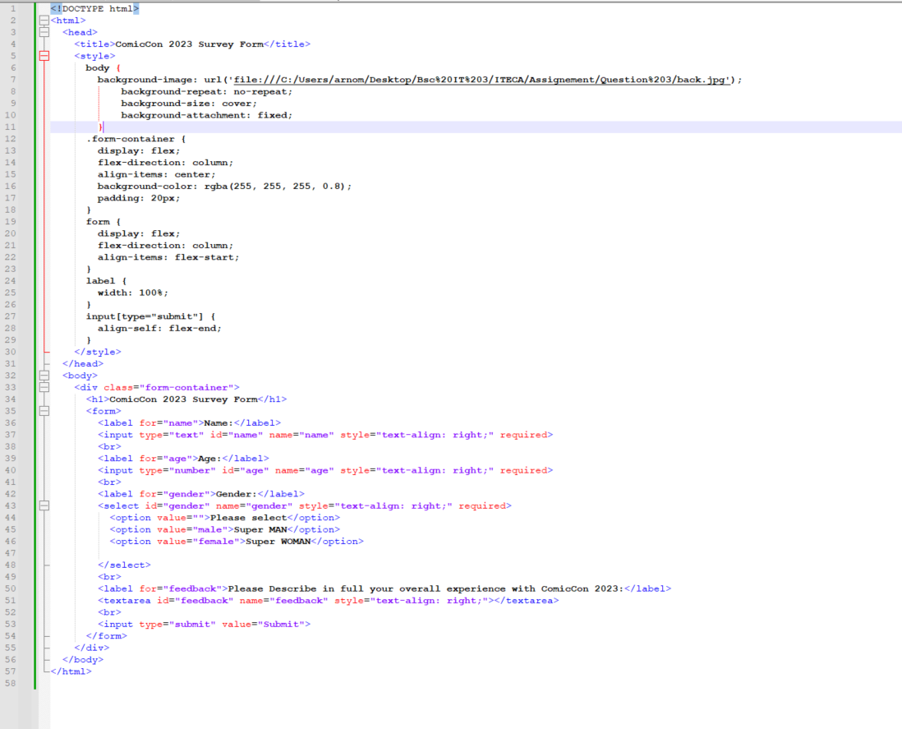

<!DOCTYPE html>

<html>

<head>

<title>ComicCon 2023 Survey Form</title>

<style>

body {

background-image: url('file:///C:/Users/arnom/Desktop/Bsc%20IT%203/ITECA/Assignement/Question%203/back.jpg');

background-repeat: no-repeat;

background-size: cover;

background-attachment: fixed;

}

.form-container {

display: flex;

flex-direction: column;

align-items: center;

background-color: rgba(255, 255, 255, 0.8);

padding: 20px;

}

form {

display: flex;

flex-direction: column;

align-items: flex-start;

}

label {

width: 100%;

}

input[type="submit"] {

align-self: flex-end;

}

</style>

</head>

<body>

<div class="form-container">

<h1>ComicCon 2023 Survey Form</h1>

<form>

<label for="name">Name:</label>

<input type="text" id="name" name="name" style="text-align: right;" required>

<br>

<label for="age">Age:</label>

<input type="number" id="age" name="age" style="text-align: right;" required>

<br>

<label for="gender">Gender:</label>

<select id="gender" name="gender" style="text-align: right;" required>

<option value="">Please select</option>

<option value="male">Super MAN</option>

<option value="female">Super WOMAN</option>

</select>

<br>

<label for="feedback">Please Describe in full your overall experience with ComicCon 2023:</label>

<textarea id="feedback" name="feedback" style="text-align: right;"></textarea>

<br>

<input type="submit" value="Submit">

</form>

</div>

</body>

</html>

# Bibliography

Clifford Stein , Robert Drysdale, Kenneth Bogart. (2011). *Discrete Mathematics for computer scientists .* United states of America: Pearson Education.

Gaddis, T. (2013). *Starting out with Programming Logic & Design.* United states: Pearson Education.

Hagarty, R. (2002). *Discrete Mathematics for computing.* Malaysia: Pearson Education limited.

Kolman, B. (1997). *Introductou Linear Algebra with applications.* New Yersey: Prentice -Hall, Inc.

RichardJohnsonbaugh. (2009). *Discrete Mathematics.* United states of America: Pearson Education.

Laudon, K. and Traver, C. 2020. E-Commerce 2020-2021: Business. Technology and Society, Global Edition, 17th Edition. Pearson UK

Nixon, R. 2021. Learning PHP, MySQL & JavaScript: With jQuery, CSS & HTML5. 6th edition. O’Reilly Media, Inc.

Nixon, R. 2015. Learning PHP, MySQL & JavaScript: With jQuery, CSS & HTML5. 4th Edition. O’Reilly Media, Sebastopol.

Schneider, G.P. 2017. Electronic commerce. 12th Edition. Cengage Learning, Boston

Afuah, A. and Tucci, C.L. 2000. Internet business models and strategies. 2nd edition. Pretoria: University of Pretoria.

Andersson, E.A., Greenspun, P. and Grumet, A. 2006. Software engineering for Internet applications. Cambridge: MIT Press.

Campbell, B. and Darnell, R. 1997. Teach yourself dynamic HTML in a week. Indianapolis: SAMS.

Chaffey, D. 2002. E-business and e-commerce management: strategy implementation and practice. 3rd edition. England: Pearson Education.

Deitel, H.M.; Deitel, P.J. and Nieto, T.R. 2001. E-business and e-commerce: how to program. New Jersey: Prentice Hall.

Laudon, K.C. and Traver, C.G. 2013. E-commerce 2014. New York: Prentice Hall.

Turban, E., King, D.R. and Lang, J. 2009. Introduction to e-commerce. New Jersey: Prentice Hall.

Ullman, L. 2014. PHP and MySQL for dynamic websites: Visual QuickPro guide. Berkeley: Peachpit Press.

Welling, L and Thomson, L. 2017. PHP and MySQL Web Development. Addison-Wesley Professional.

Complete Full Stack Website Development PHP. 2021. [Online] Available at: <https://www.youtube.com/watch?embed=no&v=jrYUUKh_lKg>. [Accessed: 13 December 2022

HTML Forms and PHP. 2021. [Online] Available at: <https://www.youtube.com/watch?embed=no&v=2HVKizgcfjo>. [Accessed: 13 December 2022].